DATA PROTECTION USING HYBRID ENCRYPTION AND STEGANOGRAPHY
Scope and Limitations
Department of Computer Science and Engineering, TKR College of Engineering & Technology
Batch A15 (CSE-A) · Academic year [ACADEMIC YEAR]
Table 1: Project team
S.No. | Student name | Roll number
1 | Allam Rakesh | 23K91A0509
2 | Bolleddu Shanker | 23K91A0543
3 | Agaram Sri Sarvagna | 23K91A0506
4 | B Akshay | 24K915A0504

Project guide: Rajalakshmi
Chapter and section numbers quoted in the text (for example Chapter 8 or Section 6.2) refer to the full project report, 17.Final Document. Figures and tables in this document are numbered from 1.

1. SCOPE

1.1 In scope
• Hybrid encryption of a single file: AES-256-GCM for the data and RSA-OAEP-SHA256 for the session key, with RSA keypairs of 2048, 3072 or 4096 bits.
• Key management in the application: generating keypairs, importing a public key (to send) or an unencrypted private key (to receive), exporting either half, and showing fingerprints.
• LSB embedding in PNG covers: one bit per R, G and B value, in raster order, with a 32-bit length header and a capacity check before embedding; files up to 25 MB can be uploaded.
• Extraction and decryption: format checks, RSA unwrap, tag verification and a SHA-256 comparison of the restored file.
• Measurement: PSNR, SSIM, MSE, capacity, bit planes, histograms and stage timings for every send; a robustness test with nine attacks; a benchmark across covers and payload sizes.
• The application: JWT sign-in, six working screens, an operation log, and a script-based evaluation (ml/eval.py, scripts/run_experiments.py) with 39 tests.

1.2 Out of scope
• Provable security and homomorphic computation as in the base paper, and hiding the location of the payload.
• Robustness engineering: error-correcting codes, transform-domain (DCT or DWT) embedding or embedding that survives JPEG.
• Adaptive and matching embedding (LSB matching, syndrome-trellis codes) and resistance to modern steganalysis.
• Authentication of the sender: there are no signatures, certificates or identity checks; anyone with the public key can send.
• Audio, video or document carriers; images other than those Pillow can decode, and any transparency (the alpha channel is dropped).
• Network delivery: CipherVeil produces a PNG; how it is transported is left to the user.
• Multi-user key sharing, key recovery and hardware key storage.

2. ASSUMPTIONS
The results depend on the following assumptions, which are choices of the project and not findings:
• Lossless channel. The stego image reaches the receiver as a PNG file with pixel values unchanged. This is the only channel for which the scheme works.
• Receiver's private key is safe. The security of the content is the security of the RSA private key; here the key is kept unencrypted in the local database and the machine is assumed to be trusted.
• Public keys are authentic. The sender is assumed to hold the right public key, because there is no certificate or fingerprint-verification protocol; the application only shows the fingerprint.
• Random sources are sound. The AES key and nonce come from the operating system's random generator (os.urandom and the cryptography library).
• Covers are ordinary images. The six committed covers stand for 'ordinary-looking' images; no claim is made for images with large flat areas, saturated regions or previous JPEG compression.
• Attacker model for the evaluation. The robustness attacks are accidental or benign processing; the steganalysis is a passive attacker with a classical detector. An active attacker who rewrites the image can always destroy the payload.
• Single user per run. The measurements were taken with one user on one machine; no concurrency was tested.

3. LIMITATIONS
The limitations below are properties of the delivered system and of the evidence, ordered by how much they affect the conclusions.
Table 2: Limitations of CipherVeil and their effect
Limitation | Evidence | Effect on the conclusions
Fragile to any lossy or geometric change | JPEG q100, q95, q75, q50, lossy WebP, noise sigma 1, resize 90 %, grayscale, palette, rotation, flip: payload lost in every case; error rate 49-50 % where measured | The stego image must travel as a PNG file; a messaging app that recompresses it destroys the message
Detectable by statistics | Chi-square p 0.97-1.00 on all 30 stego prefixes; weighted-stego estimate tracks the fill; sequential embedding from the first pixel | Imperceptible to the eye is not undetectable; low fill is safer, not safe
Location of the payload is public | Raster order from pixel 0 with a 32-bit length header, no key-dependent permutation | Secrecy rests on AES and RSA alone, not on hiding
No sender authentication | No signature in the bundle; any holder of the public key can send | The receiver cannot tell who sent a message
Unencrypted private keys at rest | keypairs.private_pem is stored in clear in SQLite | Anyone who can read data/app.db can open every message for that user
Placeholder secrets and no rate limiting | .env ships JWT_SECRET=change-me-on-first-run; no login throttle | Acceptable for a local demo only
Small, synthetic evaluation set | Six covers, four small payloads, one machine | Numbers show the behaviour of the method, not a field performance
Capacity bounded by the image | 3.0 bits per pixel, minus a bundle overhead of 401-657 bytes | A 200 x 200 cover holds 14.6 KiB; larger files need larger covers
Send page crashes for an account with no keys | Send.jsx uses the KeyRound icon without importing it (KeyRound is not defined, reproduced with a new account) | A first-time user must open Keys before Send

One limitation is a strength of the evidence rather than of the system: the closed-form PSNR model matches measurement within 0.053 dB, so the imperceptibility result does not depend on which covers were chosen. The detectability and robustness results do depend on the covers, and six covers are few.
Two figures show the limitations that matter most for reading the numbers. The first shows which channel operations the hidden bundle survives: only lossless re-encodings, and a crop that leaves the first rows intact. The second shows what a statistical detector sees: the chi-square test and the weighted-stego estimate respond to the embedded region, so a stego image that looks identical to the eye is not hidden from analysis.
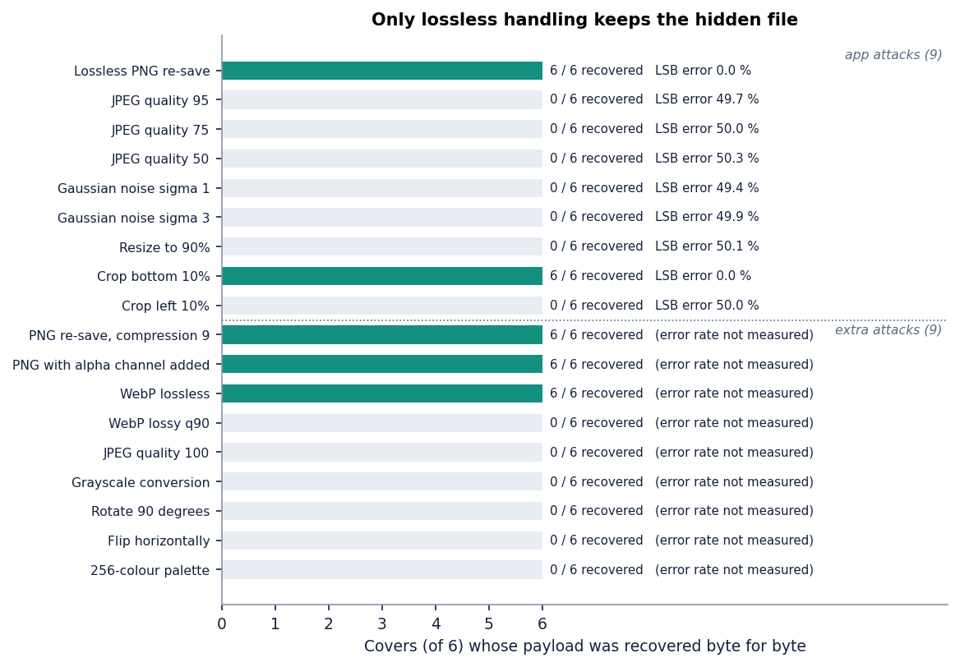
Figure 1: Payload recovery after the nine in-app attacks and nine further channel operations (6 covers each), with the LSB error rate of the core attacks.
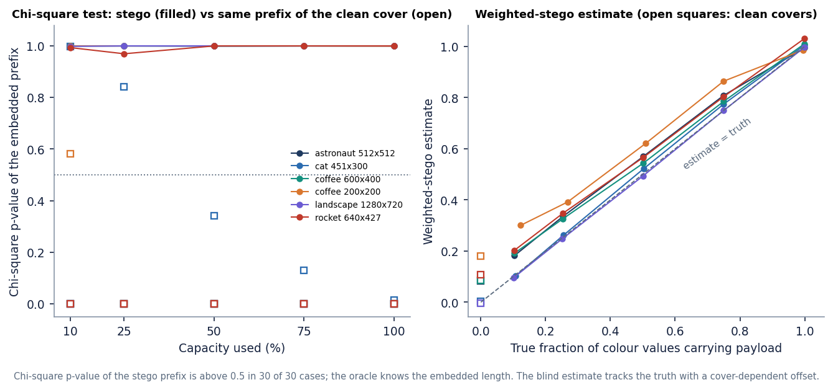
Figure 2: Chi-square p-values and weighted-stego payload estimates for clean covers and stego images at five fill levels.

4. WHAT WAS NOT MEASURED
The following were not measured, and nothing in the documents should be read as a result for them:
• Resistance to modern steganalysis: sample-pair, RS, rich-model or deep-learning detectors were not run; the chi-square test used the known payload length.
• Behaviour on camera photographs, on images that were JPEG-compressed before conversion to PNG, and on covers with flat or saturated regions.
• Transfer through real messaging or e-mail services, and what each of them does to a PNG.
• Performance with several simultaneous users, long-running stability and load behaviour of the API.
• Security testing of the web application: no penetration test, no review of the JWT in localStorage, no rate-limit test.
• Usability: no study with real users; the screens were exercised by a script.
• Energy use, memory use and mobile or embedded deployment.
• Any reproduction of the base paper's security proof or its homomorphic circuit evaluation.

